Lesson #10: Unhandled Exceptions
Part 1) Goal and Vulnerability Summary
Lesson #10 is about unhandled exceptions and excessive error details. The main affected component was the Lambda function DVSA-USER-INBOX, especially the verify path. The security impact was that the caller could receive backend error details such as errorMessage, errorType, stackTrace, and internal file paths. The main weakness was poor exception handling that exposed internal details instead of returning a safe generic error.
Part 2) Why This Works / Root Cause
This issue was possible because the verify path returned backend error details to the caller. It exposed raw exception text and status details instead of handling the error safely and returning one generic client message.
Part 3) Environment and Setup
The test was done in my own non-production AWS account in us-east-1. The main AWS service used was Lambda. The main function used was DVSA-USER-INBOX. The test was done directly in the Lambda console with a synchronous test event because the public /order path did not expose the verify action. CloudWatch Logs was used to compare internal logging with the caller-facing result. The tools used were AWS Console and CloudWatch.
Part 4) Reproduction Steps
1. Open AWS Console and go to Lambda.
2. Open the function DVSA-USER-INBOX.
3. Create a new synchronous test event.
4. Use this event JSON:
{
"action": "verify",
"user": "bad\r\nhost:evil"
}
5. Click Test.
6. Observe the returned error details in the Lambda response.
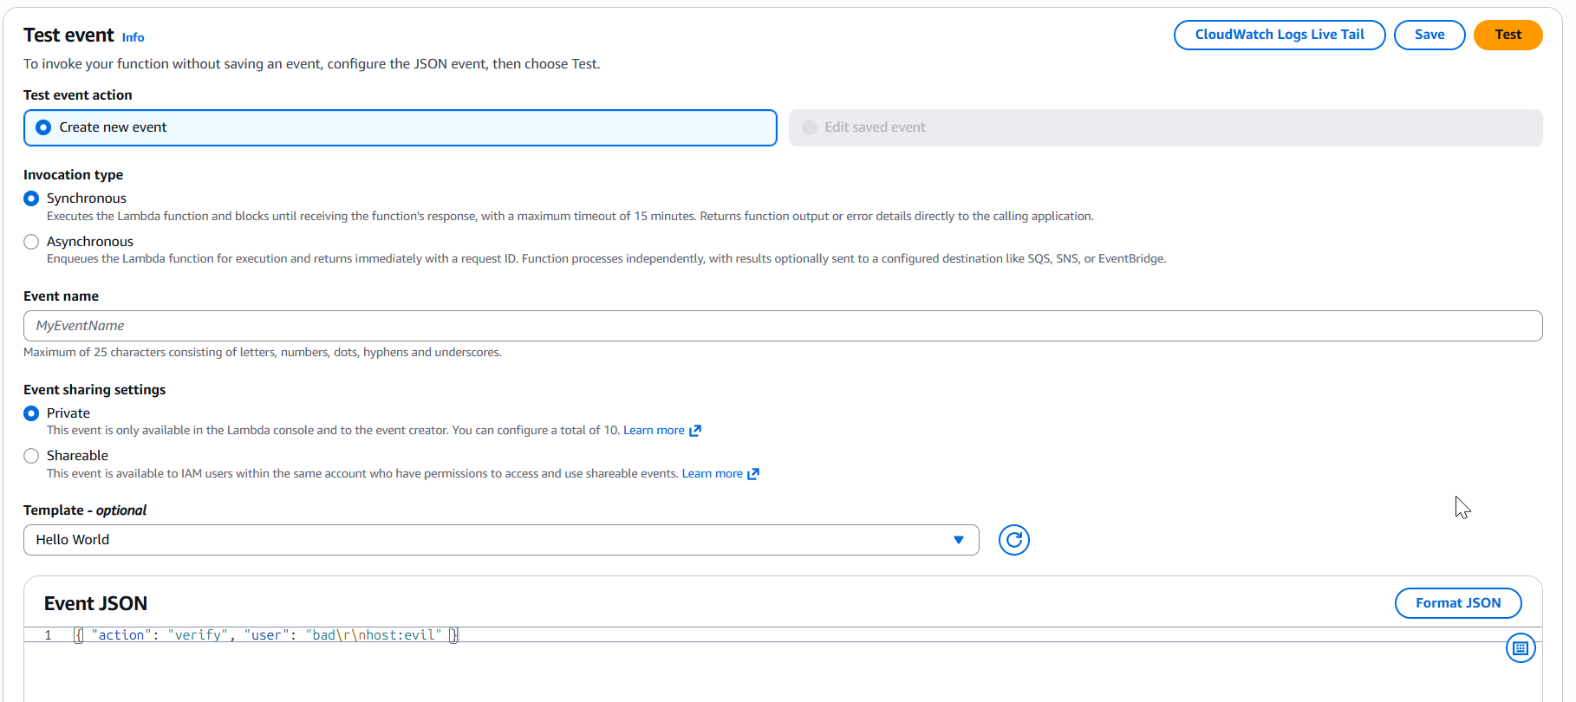
Part 5) Evidence and Proof
The vulnerability was confirmed because the caller directly received backend error details. The response showed errorMessage, errorType, stackTrace, and internal file paths such as /var/task/user_inbox.py. This proved that the function returned internal exception details instead of a safe generic error.
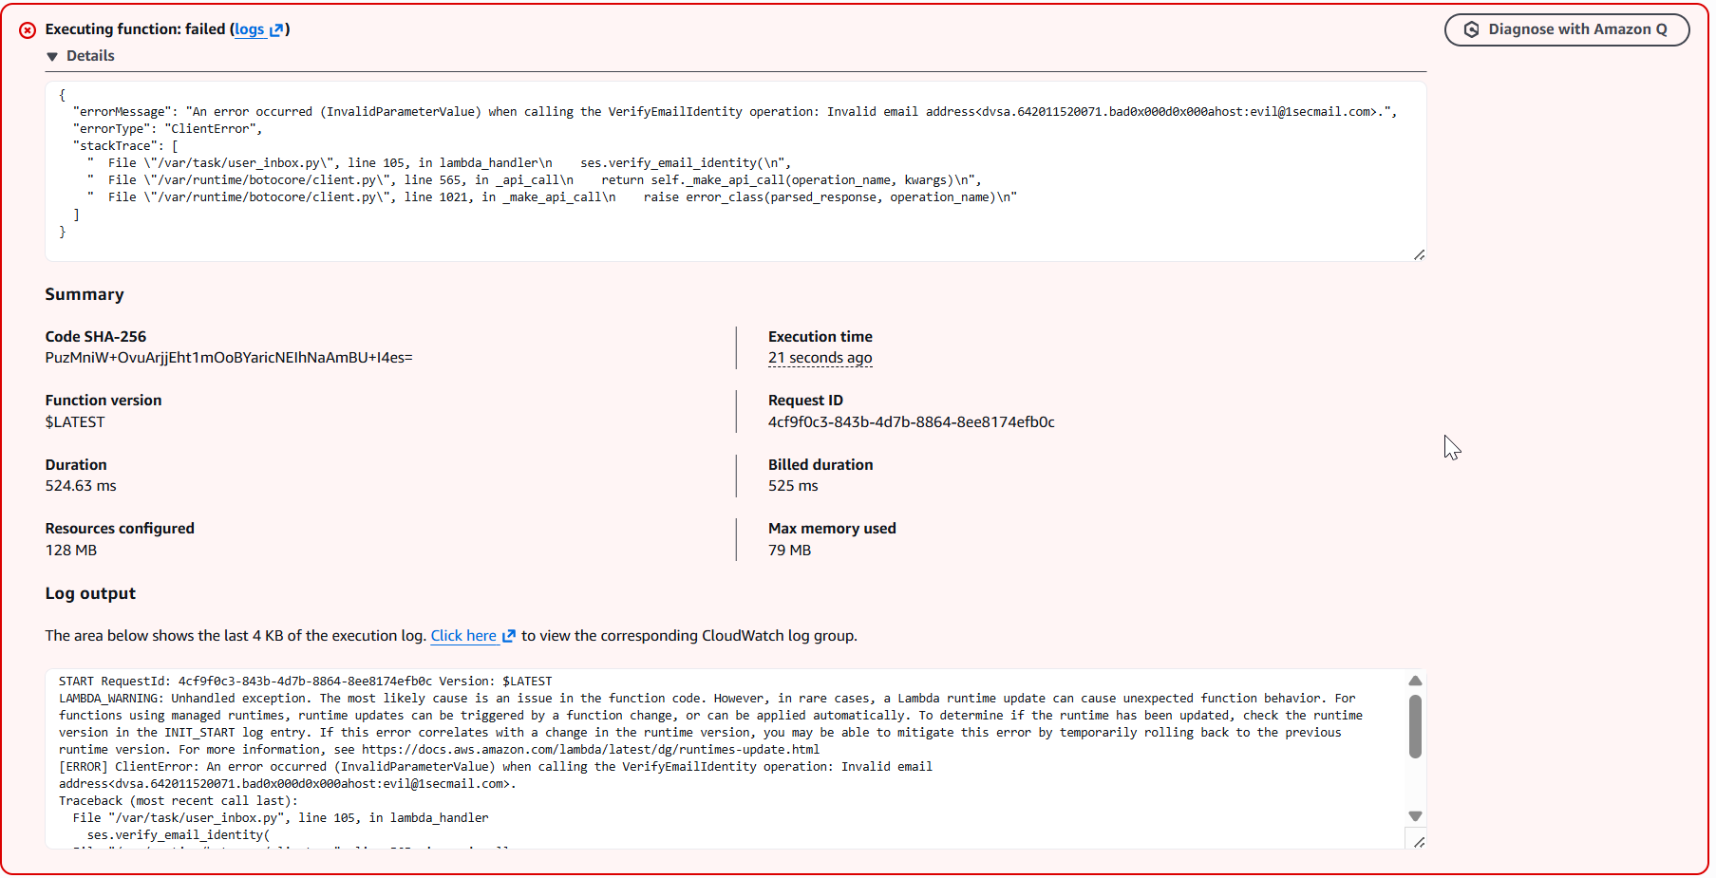
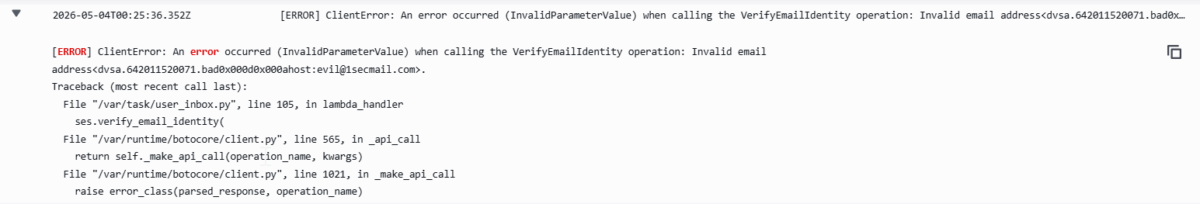
Part 6) Fix Strategy / Probable Mitigation
The fix belongs in the Lambda function DVSA-USER-INBOX, inside the verify block. The needed security improvement is to catch exceptions safely, keep detailed errors only in internal logs, and return one generic client message such as {"status":"err","msg":"could not verify email"}. This fixes the root cause because the caller no longer receives backend error details.
Part 7) Code / Config Changes
I changed the verify block in user_inbox.py inside the Lambda function DVSA-USER-INBOX. I removed the logic that returned raw exception text with str(e) and status details such as "got status code: ...". I replaced it with safe handling: print the detailed error to logs, and return only {"status":"err","msg":"could not verify email"} to the caller.
Code before:
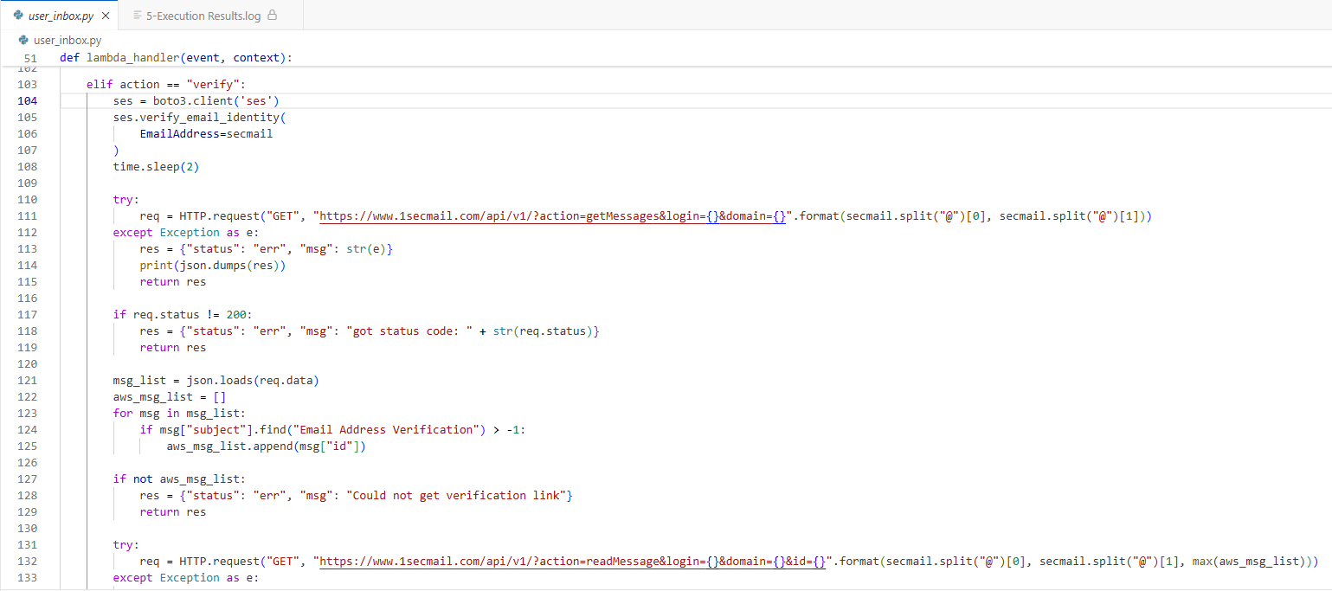
Code After:
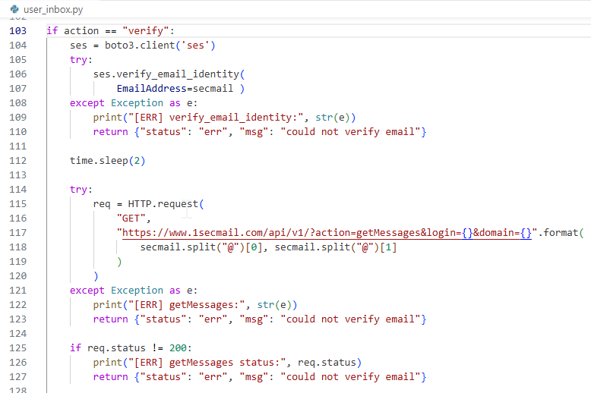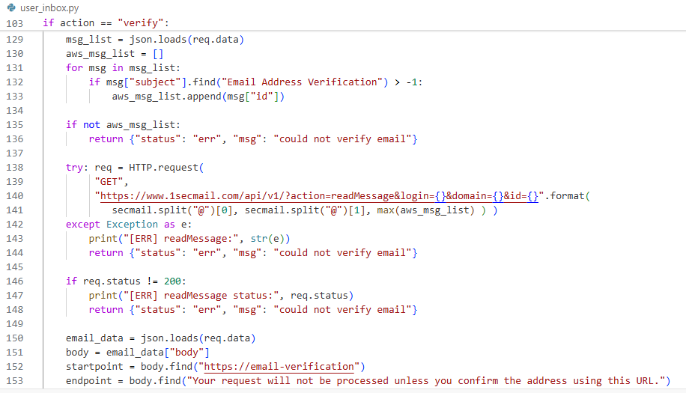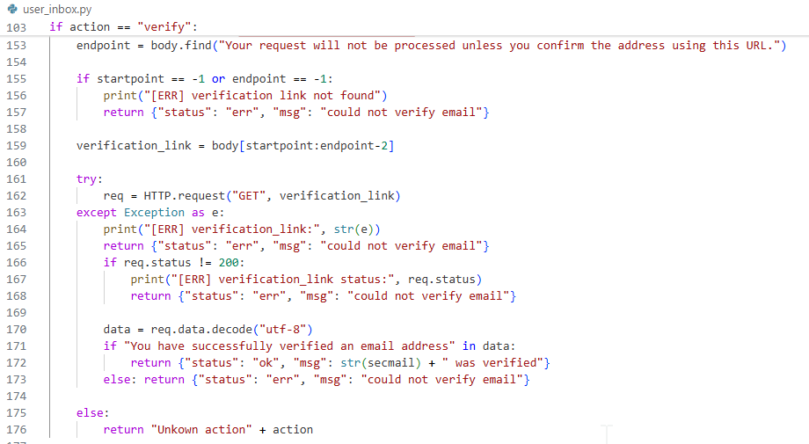

Part 8) Verification After Fix
After the fix, I ran the same malformed test event again. This time, the function returned only {"status":"err","msg":"could not verify email"}. The caller no longer received errorMessage, errorType, stackTrace, or internal file paths. This shows the vulnerable behavior no longer succeeded. Detailed diagnostics stayed only in internal logs, which is the correct behavior.
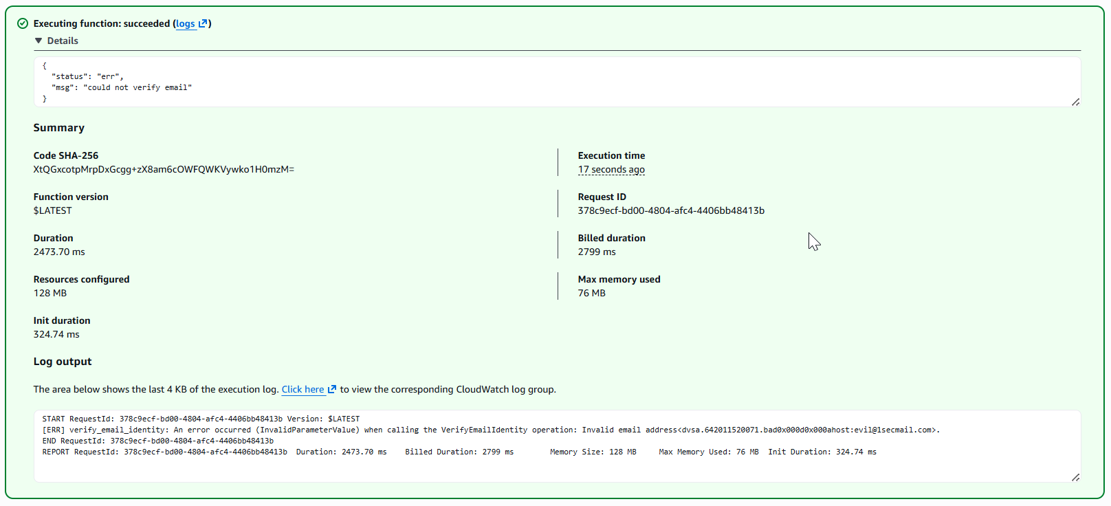

Part 9) Structured Operation and Security Analysis
The following two tables summarize the intended behavior, the exploit behavior, the deviation, the fix, and the post-fix result for Lesson #10.
Table 1: Structured analysis summary — Table A
Vulnerability | Intended Rule(s) | Artifacts Used to Infer Rule | Normal Behavior Evidence | Exploit Behavior Evidence
Lesson #10: Unhandled Exceptions | The function must not return raw backend exception details to the caller. The caller should receive only a safe generic error. | user_inbox.py source code, Lambda test event, Lambda response, CloudWatch logs | After the fix, the same malformed test returned only {"status":"err","msg":"could not verify email"}. | Before the fix, the response exposed errorMessage, errorType, stackTrace, and /var/task/user_inbox.py.

Table 2: Structured analysis summary — Table B
Vulnerability | Why This Is a Deviation | Deviation Class | Fix Applied (Where) | Post-Fix Verification | Optional Latency Before / After Logging
Lesson #10: Unhandled Exceptions | The function exposed internal backend details to the caller instead of using a safe client message. | Intentional misuse / security-relevant abuse | In DVSA-USER-INBOX (user_inbox.py), the verify block was changed to catch exceptions safely, log details internally, and return only {"status":"err","msg":"could not verify email"}. | After the fix, the same malformed input returned only the safe generic error and no stack details. | Not measured

Part 10) Takeaway / Lessons Learned
This lesson showed that the main problem was exposing backend exception details to the caller. This is important in a serverless environment because leaked stack traces, file paths, and service errors can help an attacker learn how the backend works. A safer design is to catch exceptions centrally, log details only internally, and return only generic client-safe messages.

